2022 Fall Semester In-person Mid-term Exam Notice
(for Students)

◎ Please cooperate to ensure safety and fairness for the examination
◎ Students must bring their student ID cards. (Mobile student IDs will not be recognized for midterm or final exams.)

- Precautions for Attending School
Students should never attend school and must notify the instructor under any of the following circumstances (Measures from the University Daily Recovery Support Team, Mar. 14, 2022)

[HYU Return-to-Campus(Work) Guide for COVID-19 Prevention]

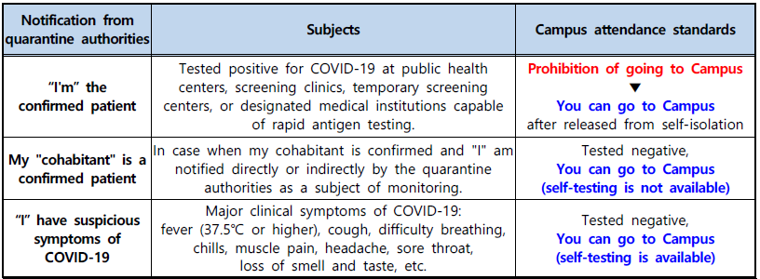

A. Students must wear a mask while attending school (Unable to enter without mask).
B. To prevent proxy examinations, students must carry their student ID card on the day of their exams. (If the student ID card has been lost, it can be substituted with an identification card, driver’s license, or passport. A mobile student ID is not an acceptable form of identification.)
C. Those who arrive at the exam location 30 minutes or more after the start of the examination will not be allowed to enter the building.

2. Precautions for Test Preparation
- While in buildings, students must wear masks at all times, and those who remove their masks will be checked-out immediately.
- Please be cooperative if a supervisor asks you to change seats or to submit to a temperature check.
- Sharing or using another’s writing instruments is prohibited to prevent the spread of infection.
- Please leave your student ID card on the top-left corner of your desk. (Student identity verification will be carried out right after the exam.)
*If your student ID card is lost, it can be substituted with an identification card, driver’s license, or passport.
*While mobile student IDs are not preferred, if the student does not have any other way to prove their identity, their mobile student ID will be checked at the end of the exam.
- Turn cell phones and electronic watches off, and if possible, separate the battery and place them in your bag and close the zipper.
* If any electronic device rings or makes any sound, it will be viewed as cheating and the student who owns it will be checked-out immediately.
- Place all unnecessary materials, including books and printouts, in your bag and close the zipper so that they can’t be seen.
3. Precautions for Test Progress
- In principle, checking-out is prohibited from the start to the end of the exam.
- Please fill out your name and student number as soon as you receive an answer sheet.
- Do not engage in any unnecessary conversations with the exam supervisors.
- When the exam supervisor goes around the room to verify that students’ faces match the photos on their student IDs and the names on their exam papers, please keep a distance from the exam supervisors.
*For students with mobile student ID, identity verification will be carried out after the exam has ended.
- Please make sure not to do anything that might be mistaken for cheating.
- Students with suspected COVID-19 symptoms such as fever (above 37.5℃), coughing, difficulty breathing, shivers, body aches, headache, sore throat, sudden loss of smell or taste, pneumonia, etc. during the exam will be required to inform the exam supervisors and then check-out immediately. (Call Student Hanyang Student Health Care Center (☎02-2220-1466~7, 1655) after checking-out and follow their instructions.)

4. Precautions for the End of the Examination
- Once the time is up, immediately stop writing.
- Once the exam concludes, students should leave sequentially according to the exam supervisor’s instructions. At that time, leave your exam sheets and answer form, in the place designated by the instructor.

<Actions Against Cheaters>
Students that have been caught engaging in any of the following acts will be considered to have cheated and will be checked-out immediately. Their exam score will be a 0. The student will need to fill out the <Cheating Confirmation Form> and the student be subject to disciplinary action from the university.
- The act of not following the exam supervisor’s request for identification or inspection of personal belongings
- The act of carrying prohibited items into the exam, or keeping them in any place contrary to the instructions of the exam supervisor
- The act of looking at other students’ answer sheets or showing one’s answer sheet to another student.
- The act of signaling to other examinees with hand gestures, sounds, etc.
- Viewing prohibited belongings or using mobile phones, electronic devices, wireless devices, etc.
- If a mobile phone, electronic device, or wireless devices makes a sound during a test, the student will be considered to have conducted an act of cheating.
- The act of forcing or threatening another examinee for answers
- A serious misconduct, such as two or more people cheating systematically and deliberately in advance.
- Requesting a proxy test or taking an exam as a substitute for the real student.
- The act of forging an identification card
- Writing answers after the end of the examination
- Other similar actions that goes against students’ duties such as cheating or past question sales

